- Terraform provider for Google Cloud
https://registry.terraform.io/providers/hashicorp/google/latest/docs
You can copy the provider code from above url from use provider section

terraform {
required_providers {
google = {
source = "hashicorp/google"
version = "5.39.1"
}
}
}

provider "google" {
project = “my-project-id”
region = “us-central1”
zone = "us-central1-a"
}

- google_compute_instance
google_compute_instance | Resources | hashicorp/google | Terraform | Terraform Registry

resource "google_compute_instance" "vm_instance" {
name = "terraform-instance"
machine_type = "n1-standard-2"
zone = "us-central1-a"

boot_disk {
initialize_params {
image = "debian-cloud/debian-11"
}
}

network_interface {
network = “default”
access_config {
}
}
}

resource block
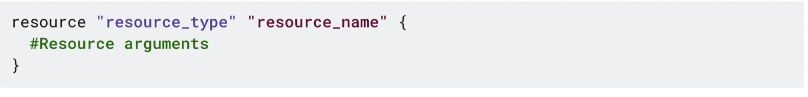

The final code in main.tf file will look like this:

terraform {
required_providers {
google = {
source = "hashicorp/google"
}
}
}

provider "google" {
project = "qwiklabs-gcp-01-79958e90933a"
region = "us-east1"
zone = "us-east1-c"
}

resource "google_compute_instance" "terraform" {
name = "terraform"
machine_type = "e2-micro"
tags = ["web", "dev"] #optionalNetworktags
boot_disk {
initialize_params {
image = "debian-cloud/debian-11"
}
}
network_interface {
network = "default"
access_config {
}
}
}

- google_storage_bucket
https://registry.terraform.io/providers/hashicorp/google/latest/docs/resources/storage_bucket

resource "google_storage_bucket" "static-site" {
name = "image-store.com"
location = "EU"
force_destroy = true

uniform_bucket_level_access = true

website {
main_page_suffix = "index.html"
not_found_page = "404.html"
}
cors {
origin = ["http://image-store.com"]
method = ["GET", "HEAD", "PUT", "POST", "DELETE"]
response_header = ["*"]
max_age_seconds = 3600
}
}

- google_compute_network

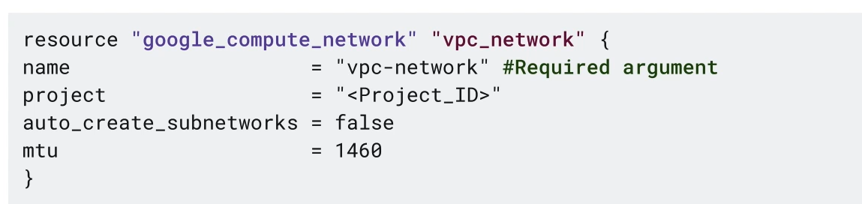

- google_compute_subnetwork

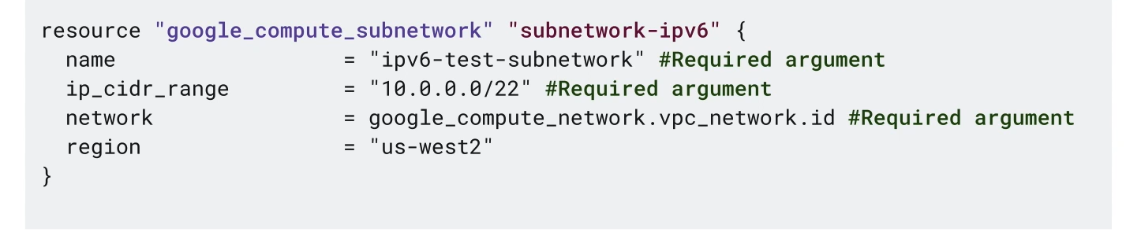

- google_compute_image
https://registry.terraform.io/providers/hashicorp/google/latest/docs/resources/compute_image.html

resource "google_compute_image" "example" {
name = "example-image"

raw_disk {
source = "https://storage.googleapis.com/bosh-gce-raw-stemcells/bosh-stemcell-97.98-google-kvm-ubuntu-xenial-go_agent-raw-1557960142.tar.gz"
}
}

Creating Resource Dependencies with Terraform
- Implicit dependencies: Dependencies known to Terraform
- Explicit dependencies: Dependencies unknown to Terraform

- View Implicit Resource Dependency

provider.tf

provider "google" {
project = "qwiklabs-gcp-04-03183feeb584"
region = "europe-west4"
zone = "europe-west4-b"
}

- Initialize Terraform by running the following commands:

- terraform init

instance.if

# add to your configuration by assigning a static IP to the VM instance in instance.tf #Assign a static IP

resource "google_compute_address" "vm_static_ip" {
name = "terraform-static-ip"
}

resource google_compute_instance "vm_instance" {
name = "${var.instance_name}"
zone = "${var.instance_zone}"
machine_type = "${var.instance_type}"
boot_disk {
initialize_params {
image = "debian-cloud/debian-11"
}
}
network_interface {
network = "default"
access_config {
# Allocate a one-to-one NAT IP to the instance
nat_ip = google_compute_address.vm_static_ip.address
}
}
}

variables.tf

variable "instance_name" {
type = string
description = "Name for the Google Compute instance"
}
variable "instance_zone" {
type = string
description = "Zone for the Google Compute instance"
}
variable "instance_type" {
type = string
description = "Disk type of the Google Compute instance"
default = "e2-medium"
}

outputs.tf
output "network_IP" {
value = google_compute_instance.vm_instance.instance_id
description = "The internal ip address of the instance"
}
output "instance_link" {
value = google_compute_instance.vm_instance.self_link
description = "The URI of the created resource."
}

- Initialize terraform by running the following command.
- terraform init
- Run the following command to preview the resources created.
- terraform plan
- If prompted, enter the details for the instance creation as shown below:
- var.instance_name: myinstance
- var.instance_zone: europe-west4-b
- Run the following command to view the order of resource creation.
- terraform apply
- If prompted, enter the details for the instance creation as shown below:
- var.instance_name: myinstance
- var.instance_zone: europe-west4-b
Note: Observe that Terraform handles implicit dependency automatically by creating a static IP address before the instance.
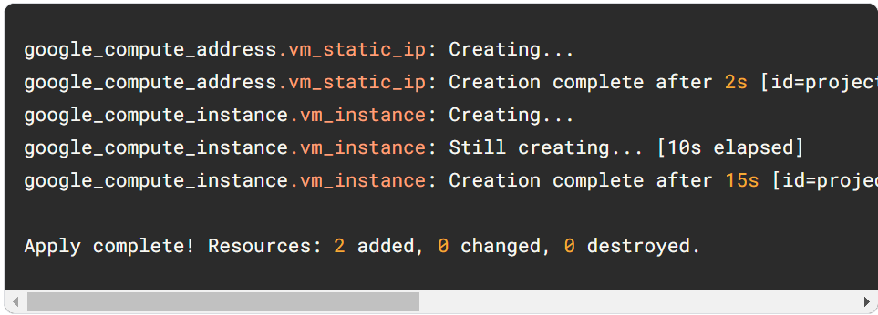
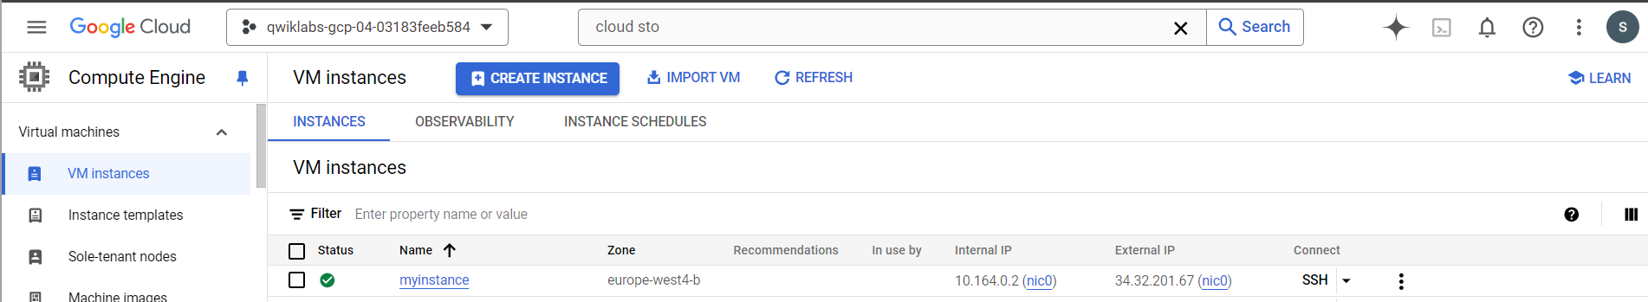

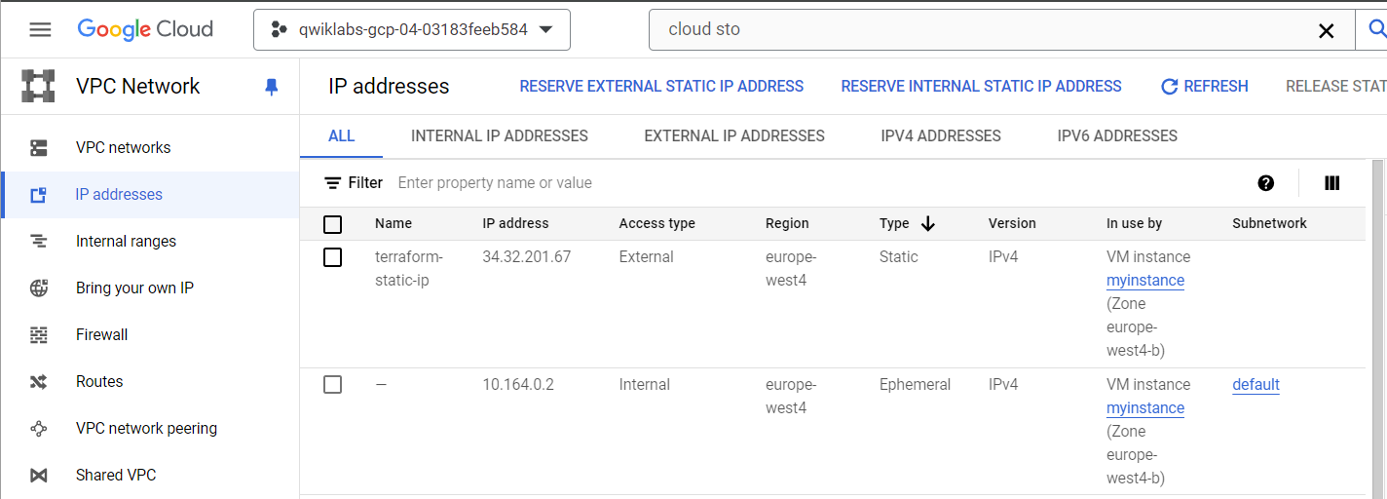

- Create Explicit Dependency
Explicit dependencies are used to inform dependencies between resources that are not visible to Terraform. In this example, consider that you will run on your instance that expects to use a specific Cloud Storage bucket, but that dependency is configured inside the application code and thus not visible to Terraform. In that case, you can use depends_on to explicitly declare the dependency.
exp.tf

resource "google_compute_instance" "another_instance" {

name = "terraform-instance-2"
machine_type = "e2-micro"
boot_disk {
initialize_params {
image = "debian-cloud/debian-11"
}
}
network_interface {
network = "default"
access_config {
}
}
# Tells Terraform that this VM instance must be created only after the
# storage bucket has been created.
depends_on = [google_storage_bucket.example_bucket]
}

# Add the following code to create a bucket.

resource "google_storage_bucket" "example_bucket" {
name = "sab-storage-bucket-us"
location = "US"
website {
main_page_suffix = "index.html"
not_found_page = "404.html"
}
}

Notice that in our code the VM instance configuration is added before the GCS bucket. When executing Terraform apply you will notice that the order that resources are defined in a terraform configuration file has no effect on how Terraform applies your changes.

• Run the following command to preview the resources created.
- terraform plan
• If prompted, enter the details for the instance creation as shown below:
- var.instance_name: myinstance
- var.instance_zone: europe-west4-b
• Run the following command to view the order of resource creation.
- terraform apply
• If prompted, enter the details for the instance creation as shown below:
- var.instance_name: myinstance
- var.instance_zone: europe-west4-b

Observe that due explicit dependency, the compute instance is created after the creation of the Cloud Storage Bucket.

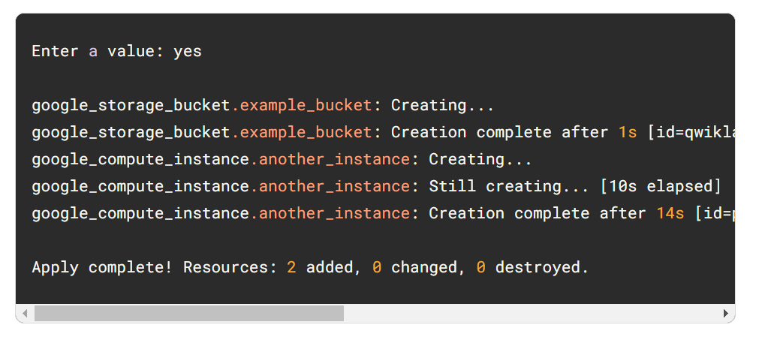
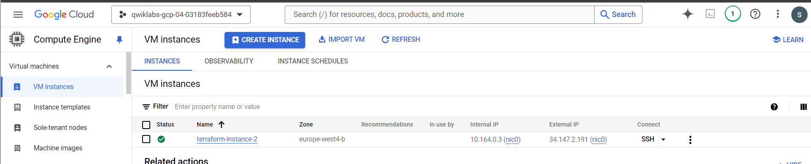
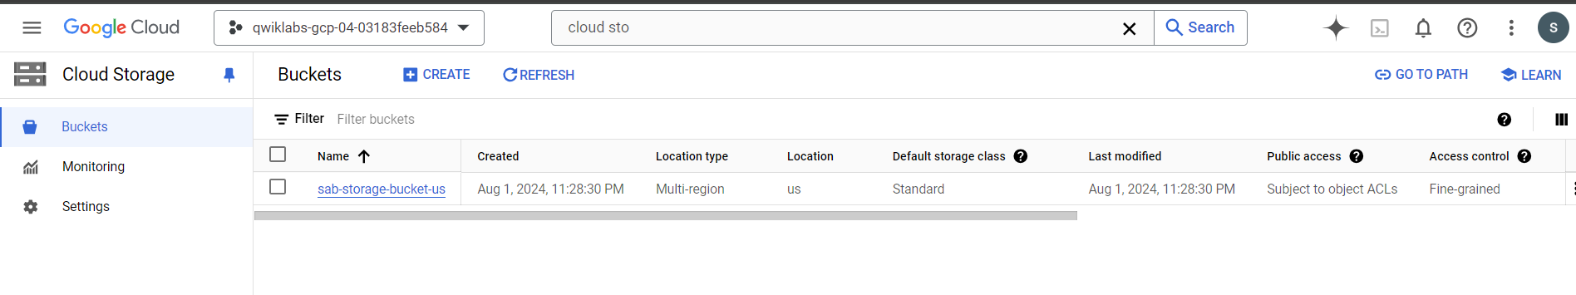
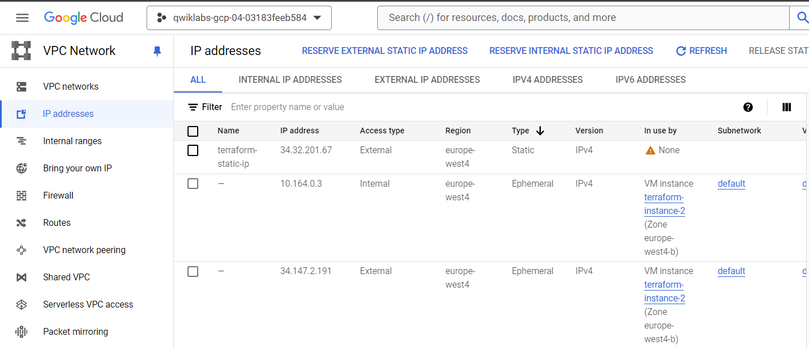

Automating the Deployment of Infrastructure Using Terraform
- Initialize Terraform
To create a directory for your Terraform configuration, run the following command:
- mkdir tfinfra
- cd tfinfra
- touch provider.tf
- vi provider.tf
Copy the code into provider.tf
provider "google" {}

- terraform init

- Create mynetwork and its resources
Create the auto mode network mynetwork along with its firewall rule and two VM instances (mynet_us_vm and mynet_eu_vm).

- Configure mynetwork

- touch mynetwork.tf
Copy the following base code into mynetwork.tf
# Create the mynetwork network
resource "google_compute_network" "mynetwork" {
name = "mynetwork"
# RESOURCE properties go here
auto_create_subnetworks = "true"
}

By definition, an auto mode network automatically creates a subnetwork in each region. Therefore, you are setting auto_create_subnetworks to true.

- Configure the firewall rule

Define a firewall rule to allow HTTP, SSH, RDP, and ICMP traffic on mynetwork.
Add the following base code to mynetwork.tf

# Add a firewall rule to allow HTTP, SSH, RDP and ICMP traffic on mynetwork
resource "google_compute_firewall" "mynetwork-allow-http-ssh-rdp-icmp" {
name = "mynetwork-allow-http-ssh-rdp-icmp"
# RESOURCE properties go here
network = google_compute_network.mynetwork.self_link
allow {
protocol = "tcp"
ports = ["22", "80", "3389"]
}
allow {
protocol = "icmp"
}
source_ranges = ["0.0.0.0/0"]
}

Verify that your mynetwork.tf file look like this

# Create the mynetwork network
resource "google_compute_network" "mynetwork" {
name = "mynetwork"
# RESOURCE properties go here
auto_create_subnetworks = "true"
}
# Add a firewall rule to allow HTTP, SSH, RDP and ICMP traffic on mynetwork
resource "google_compute_firewall" "mynetwork-allow-http-ssh-rdp-icmp" {
name = "mynetwork-allow-http-ssh-rdp-icmp"
# RESOURCE properties go here
network = google_compute_network.mynetwork.self_link
allow {
protocol = "tcp"
ports = ["22", "80", "3389"]
}
allow {
protocol = "icmp"
}
source_ranges = ["0.0.0.0/0"]
}

- Configure the VM instance

create a new folder inside tfinfra. Name the new folder instance

- cd instance
- main.tf
Copy the following base code into main.tf

resource "google_compute_instance" "vm_instance" {
name = "${var.instance_name}"
zone = "${var.instance_zone}"
machine_type = "${var.instance_type}"
boot_disk {
initialize_params {
image = "debian-cloud/debian-11"
}
}
network_interface {
network = "${var.instance_network}"
access_config {
# Allocate a one-to-one NAT IP to the instance
}
}
}

- cd variable.tf
Define the 4 input variables in variables.tf

variable "instance_name" {}
variable "instance_zone" {}
variable "instance_type" {
default = "e2-micro"
}
variable "instance_network" {}

By giving instance_type a default value, you make the variable optional. The instance_name, instance_zone, and instance_network are required, and you will define them in mynetwork.tf.
You should have the following folder structure in Cloud Shell:
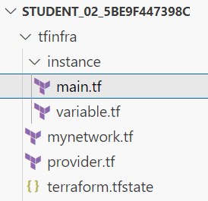

Add the following VM instances to mynetwork.tf

# Create the mynet-us-vm instance
module "mynet-us-vm" {
source = "./instance"
instance_name = "mynet-us-vm"
instance_zone = "us-east4-b"
instance_network = google_compute_network.mynetwork.self_link
}

# Create the mynet-eu-vm" instance
module "mynet-eu-vm" {
source = "./instance"
instance_name = "mynet-eu-vm"
instance_zone = "europe-west4-c"
instance_network = google_compute_network.mynetwork.self_link
}

Verify that mynetwork.tf looks like this, including brackets {}
# Create the mynetwork network
resource "google_compute_network" "mynetwork" {
name = "mynetwork"
# RESOURCE properties go here
auto_create_subnetworks = "true"
}
# Add a firewall rule to allow HTTP, SSH, RDP and ICMP traffic on mynetwork
resource "google_compute_firewall" "mynetwork-allow-http-ssh-rdp-icmp" {
name = "mynetwork-allow-http-ssh-rdp-icmp"
# RESOURCE properties go here
network = google_compute_network.mynetwork.self_link
allow {
protocol = "tcp"
ports = ["22", "80", "3389"]
}
allow {
protocol = "icmp"
}
source_ranges = ["0.0.0.0/0"]
}
# Create the mynet-us-vm instance
module "mynet-us-vm" {
source = "./instance"
instance_name = "mynet-us-vm"
instance_zone = "us-east4-b"
instance_network = google_compute_network.mynetwork.self_link
}
# Create the mynet-eu-vm" instance
module "mynet-eu-vm" {
source = "./instance"
instance_name = "mynet-eu-vm"
instance_zone = "europe-west4-c"
instance_network = google_compute_network.mynetwork.self_link
}

- Create mynetwork and its resources
To go back to tfinfra
- cd tfinfra
To rewrite the Terraform configuration files to a canonical format and style, run the following command:
- terraform fmt
To initialize Terraform, run the following command:
- terraform init
To create an execution plan, run the following command:
- terraform plan
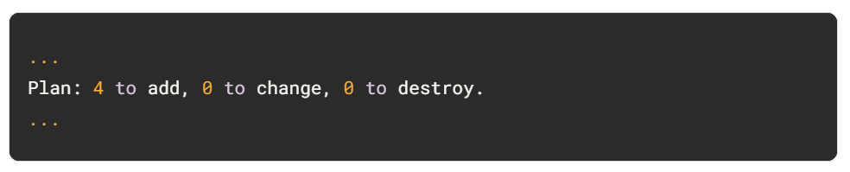
Terraform determined that the following 4 resources need to be added:
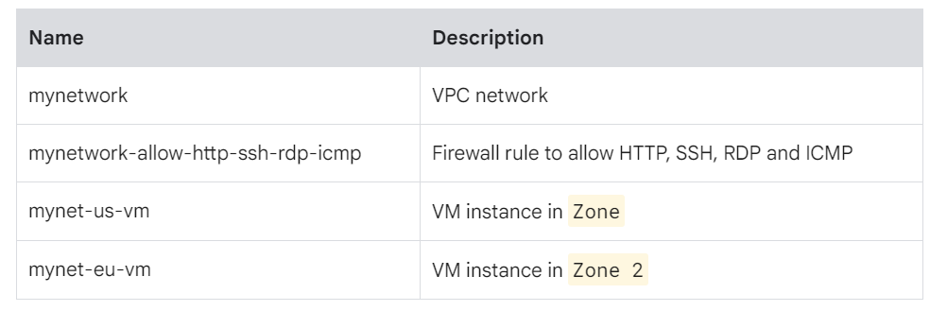
To apply the desired changes, run the following command:
- terraform apply
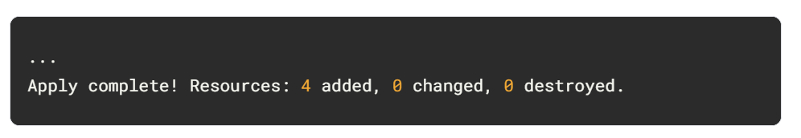
- Verify your deployment

In the Cloud Console, on the Navigation menu (Navigation menu icon), click VPC network > VPC networks. View the mynetwork VPC network with a subnetwork in every region.

On the Navigation menu, click VPC network > Firewall. View the mynetwork-allow-http-ssh-rdp-icmp firewall rule for mynetwork.

On the Navigation menu (Navigation menu icon), click Compute Engine > VM instances. View the mynet-us-vm and mynet-eu-vm instances. Note the internal IP address for mynet-eu-vm. For mynet-us-vm, click SSH to launch a terminal and connect. To test connectivity to mynet-eu-vm's internal IP address, run the following command in the SSH terminal (replacing mynet-eu-vm's internal IP address with the value noted earlier):

- ping -c 3 <Enter mynet-eu-vm's internal IP here>
This should work because both VM instances are on the same network, and the firewall rule allows ICMP traffic!

Creating a Remote Backend
- Add a local backend
In a new Cloud Shell window, create a main.tf configuration file.
- touch main.tf
Copy the Cloud Storage bucket resource code into your main.tf configuration file:
provider "google" {
project = "qwiklabs-gcp-00-f9dccb133d2d"
region = "us-west1"
}
resource "google_storage_bucket" "test-bucket-for-state" {
name = "qwiklabs-gcp-00-f9dccb133d2d"
location = "US" # Replace with EU for Europe region
uniform_bucket_level_access = true
}

Add a local backend to your main.tf file:

terraform {
backend "local" {
path = "terraform/state/terraform.tfstate"
}
}

This will reference a terraform.tfstate file in the terraform/state directory.
The final code in main.tf is as shown below.
provider "google" {
project = "qwiklabs-gcp-00-f9dccb133d2d"
region = "us-west1"
}
resource "google_storage_bucket" "test-bucket-for-state" {
name = "qwiklabs-gcp-00-f9dccb133d2d"
location = "US" # Replace with EU for Europe region
uniform_bucket_level_access = true
}
terraform {
backend "local" {
path = "terraform/state/terraform.tfstate"
}
}

- terraform init
- terraform apply
The Cloud Shell Editor should now display the state file called terraform.tfstate in the terraform/state directory.
- terraform show
Your google_storage_bucket.test-bucket-for-state resource should be displayed.
- Add a Cloud Storage backend

To change the existing local backend configuration, replace the code for local backend with the following configuration in the main.tf file.
terraform {
backend "gcs" {
bucket = "qwiklabs-gcp-00-f9dccb133d2d"
prefix = "terraform/state"
}
}

The final code in main.tf is as shown below:
provider "google" {
project = "qwiklabs-gcp-00-f9dccb133d2d"
region = "us-west1"
}
resource "google_storage_bucket" "test-bucket-for-state" {
name = "qwiklabs-gcp-00-f9dccb133d2d"
location = "US" # Replace with EU for Europe region
uniform_bucket_level_access = true
}
terraform {
backend "gcs" {
bucket = "qwiklabs-gcp-00-f9dccb133d2d"
prefix = "terraform/state"
}
}

- terraform init -migrate-state
In the Cloud Console, in the Navigation menu, click Cloud Storage and then Bucket. Click on your bucket and navigate to the file terraform/state/default.tfstate.

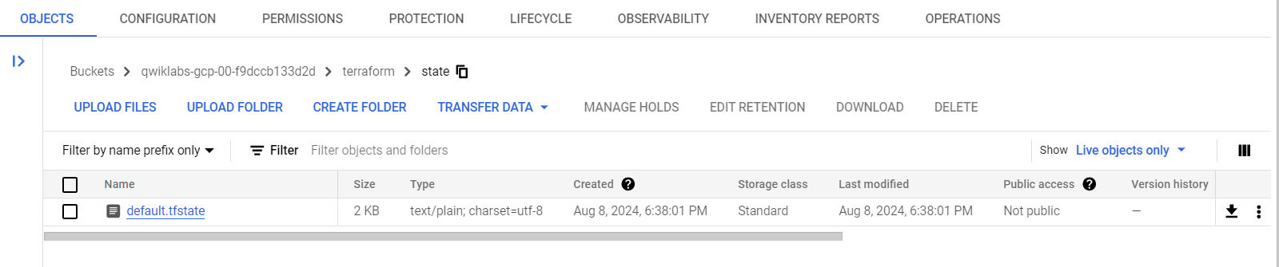
- Refresh the state
Return to your storage bucket in the Cloud Console. Select the check box next to the name, and click the Labels button on the top. The info panel with Permissions and Labels tabs will open up.

Click the Labels tab. Click +ADD LABEL. Set the Key1 = key and Value1 = value. Click Save.

Return to Cloud Shell and use the following command to update the state file:
- terraform refresh

google compute instance

resource "google_compute_instance" "example_instance" {
name = "example-instance"
machine_type = "n2-standard-2"
zone = "us-central1-c"

boot_disk {
initialize_params {
image = "projects/sab-ssvcs-gold-images-c3d9/global/images/sabre-ol-8-default-rc-202408240800"
}
}

network_interface {
network = "projects/sab-ssvcs-network-vpcs-5041/global/networks/vpc-dev"
subnetwork = "projects/sab-ssvcs-network-vpcs-5041/regions/us-central1/subnetworks/sn-dev-uscentral1-01"

}

tags = ["default-uscentral1"]

metadata = {
"startup-script" = <<-EOT
#!/bin/bash
echo "Hello, World!" > /var/log/startup-script.log
EOT
"amt-idm-hostprofile" = "gcphlpdsk"
"amt-enable-dsagent" = "false"
"amt-enable-cortexagent" = "true"
}

labels = {
environment = "dev"
}

service_account {
email = "100035846843-compute@developer.gserviceaccount.com"
scopes = ["https://www.googleapis.com/auth/cloud-platform"]
}
}

Variable.tf
variable "linux_machine_type" {
default = "n2-standard-2"
type = string
description = " The type of machine to be used for the instance"
}
variable "image_name" {
description = "The name of the image to be used for the instance"
type = string
default = "sabre-ol-8-default-rc-202408240800"
}

variable "image_project" {
description = "The project where the image is located"
type = string
default = "sab-ssvcs-gold-images-c3d9"
}

variable "zone" {
description = "The GCP zone where the instance will be deployed"
type = string
default = "us-central1-a"
}

variable "source_image" {
default = "projects/sab-ssvcs-gold-images-c3d9/global/images/sabre-ol-8-default-ga-202407010600"
}

Use above variable to create compute image in sab-dev-helpdesk-sandbox-3685 project
resource "google_compute_image" "example-image" {
name = "sab-ol8-test-image"
source_image = "projects/${var.image_project}/global/images/${var.image_name}"
}

resource "google_compute_image" "example-image" {
name = "sab-ol8-test-image"
source_image = var.source_image
}

provider.tf
terraform {
required_providers {
google = {
source = "hashicorp/google"
version = "6.0.1"
}
}
}

provider "google" {
project = local.project_id
region = "us-central1"
zone = "us-central1-c"
}

locals.tf
locals {
project_id = "sab-dev-helpdesk-sandbox-3685" //global variable
}

Use above variables to create google compute instance in sab-dev-helpdesk-sandbox-3685 project
resource "google_compute_instance" "my_instance" {
name = "my-instance"
machine_type = var.machine_type
zone = var.zone

boot_disk {
initialize_params {
image = "projects/${var.image_project}/global/images/${var.image_name}"
}
}

network_interface {
network = "projects/sab-ssvcs-network-vpcs-5041/global/networks/vpc-dev"
subnetwork = "projects/sab-ssvcs-network-vpcs-5041/regions/us-central1/subnetworks/sn-dev-uscentral1-01"
}

metadata = {
startup-script = <<-EOT
#!/bin/bash
echo "Hello, world!" > /var/www/html/index.html
EOT
}

tags = ["default-uscentral1"]
}

IAM policy for projects
Four different resources help you manage your IAM policy for a project. Each of these resources serves a different use case:
- google_project_iam_policy: Authoritative. Sets the IAM policy for the project and replaces any existing policy already attached.
- google_project_iam_binding: Authoritative for a given role. Updates the IAM policy to grant a role to a list of members. Other roles within the IAM policy for the project are preserved.
- google_project_iam_member: Non-authoritative. Updates the IAM policy to grant a role to a new member. Other members for the role for the project are preserved.
- google_project_iam_audit_config: Authoritative for a given service. Updates the IAM policy to enable audit logging for the given service.

- google_project_iam_policy 110 to define a complete policy for the project.
- google_project_iam_binding 629 to define all the members of a single role.
- google_project_iam_member 891 to define a single role binding for a single principal.
resource "google_service_account" "google-sa" {
account_id = "gcp-helpdesk-sa"
display_name = "gcp-hd-sa"
}

resource "google_project_iam_member" "compute-image-user" {
project = local.project_id
role = "roles/compute.imageUser"
member = "serviceAccount:${google_service_account.google-sa.email}"
}

resource "google_project_iam_member" "compute-network-user" {
project = local.project_id
role = "roles/compute.networkUser"
member = "serviceAccount:${google_service_account.goolgle-sa.email}"
}

resource "google_project_iam_member" "compute_instance_admin" {
project = local.project_id
role = "roles/compute.instanceAdmin"
member = "serviceAccount:${google_service_account.goolgle-sa.email}"
}

output "service_account_email" {
value = google_service_account.example.email
}

resource "google_compute_image" "example-image" {
name = "sab-ol8-test-image"
source_image = "projects/sab-ssvcs-gold-images-c3d9/global/images/sabre-ol-8-default-ga-202407010600"
}

# Create a Google Cloud Storage Bucket
resource "google_storage_bucket" "example" {
name = "example-bucket-<UNIQUE_SUFFIX>" # Bucket names must be globally unique
location = "US"
storage_class = "STANDARD"
uniform_bucket_level_access = true

# Retention Policy
retention_policy {
retention_period = 3600 # Default retention period in seconds, e.g., 3600 seconds = 1 hour
is_locked = false
}

versioning {
enabled = true
}

lifecycle {
prevent_destroy = true # Optional: Prevent accidental deletion
}

labels = {
environment = "production"
}

# Access Control Configuration
acl {
role_entity = [
"READER:allUsers",
"OWNER:projectEditor:<YOUR_PROJECT_ID>",
]
}
}

output "bucket_name" {
value = google_storage_bucket.example.name
}

